Guideline for Drafting Academic Papers
Ⅰ. Drafting of the draft for papers and submission
A. Submission eligibility
Party who registered with our graduate school and who earned at least required GPA (at least 3.0), or the party who is expected to
B. Drafting and submission method
① Need to submit three copies of the initial draft for the (hereafter, “paper”) to our graduate school's Academic Affairs within specified deadline.
② Include one copy of the document for the approval of paper submission (template on the attachment No. 1)
③ Pay specified paper review fee
Ⅱ. Drafting and submission of the final paper
A. Submission eligibility
Judge notifies the dean of the graduate school that the draft paper was approved by the Paper Review Committee. Then, draft paper submitter (template on the attachment No. 2) needs to draft and submit the final paper.
B. Drafting and submission method
(1) Final paper should be drafted according to the guideline for drafting final paper specified in the following sub clause.
(2) Need to submit four copies to our graduate school's Academic Affairs within the specified deadline.
Ⅲ. Paper drafting guideline
A. Paper drafting guideline for the template, paper and book binding
(1) Paper should be written horizontally in Korean or in foreign language.
(2) As for the paper used, use white typing paper of the 19.5cm×25.5cm specs or 80 simili after book binding.
(3) Leave margin of 2.0cm at the upper, lower, right and left sections of the paper.
(4) Double space everything unless there is separate rule, and print only one side of the paper in black.
(5) When book binding, the cover should be covered with the black cloth. After book binding, the book should measure 19.5cm and 25.5cm in width and length, respectively.
(6) The outer cover should comply with the template on the attachment No. 3, and the letters should be engraved in gold leaf. If considered necessary, it is possible to add on sub-title below the paper's title.
(7) Attach white simili at the inner side of the outer cover, and the end papers should be 120 simili. Then, place in the inner cover(template of the attachment No. 3 like the outer cover).
B. Paper recording sequence and method
(1) Inner cover
Comply with the template of the attachment No. 3.
(2) Place in the template of the attachment No. 4.
(3) Paper approval document
Comply with the template of the attachment No. 5.
(4) Acknowledgment
Paper submitter writes this to express gratitude to the advisor and other individuals and groups.
(5) Table of Contents
When dividing up the Table of Contents into categories, it should be divided into Ⅰ-A-①-(a), or chapter-paragraph-①-(A).
<Example>
Table of Contents
Ⅰ. Introduction
Ⅱ. Theoretical background(previous studies)
Ⅲ. Method
A. ○ ○ ○
B. ○ ○ ○
Ⅳ. Results
A. ○ ○ ○
(1) ○ ○ ○
(2) ○ ○ ○
(a) ○ ○ ○
(b) ○ ○ ○
(5) List of Tables and List of Figures
Attach serial number such as Chart 1, Chart 2, …Figure 1, Figure 2, … and input the titles.
(6) Abstract
Write the abstract both in Korean and English. If the text is in Korean, then place the abstract drafted in foreign language first, and place the abstract in Korean first if the text is in a foreign language.
(7) Text
(a) The text should include the following.
Introduction
Text
Conclusion
(b) Paper should include reference and content footnote in the form of foot-note, attach serial number, and mark in Arabic number. Foot-note should be written below the applicable side.
<Example>
◦◦◦◦◦◦◦◦◦◦◦(1)◦◦◦◦◦◦◦◦◦(2)◦◦◦◦◦◦◦◦◦◦◦◦◦◦◦◦◦◦◦◦◦◦◦◦◦◦◦◦◦◦◦◦◦◦◦◦◦
① ◦◦◦◦◦◦◦◦◦◦◦◦◦◦◦◦◦◦◦◦◦◦◦◦◦◦◦◦◦
◦◦◦◦◦◦◦◦◦◦◦◦◦◦◦◦◦◦◦◦◦◦◦◦◦◦◦
② ◦◦◦◦◦◦◦◦◦◦◦◦◦◦◦◦◦◦◦◦◦◦◦◦◦◦◦◦◦
◦◦◦◦◦◦◦◦◦◦◦◦◦◦◦◦◦◦◦◦◦◦◦◦◦◦◦
(8) Bibliography
When the text is complete, then distinguish the references used for the paper drafting into overseas or domestic data, and list down according to the author's name in the order of ga, na, da or abc.
C. Reference listing method
(1) When a reference is a separate volume, then list down using the following sequence.
1. Names of the author and editor
Name of a foreigner should be written in as John A. Smith(or J.A. Smith). However, name of a foreigner should be written in as Smith, John A. in the paper's reference section. Write in the (편) or (ed.) after the editor's name.
2. Year published
Write in the year published after the name of the author or editor.
3. Name of the book
Underline.
4. Name of the translator
If a book is translated, then write in the name of the translator after the book's name such as translated by ◦◦ or trans. G.T. Thompson.
5. Matters pertaining to the publication
Enter in the following matters in the parenthesis. If necessary, enter in the (A)(B)(C).
(A) Total volumes published
(B) Total number of books published/sold in terms of the initial edition, revised version, third revised version
(C) Series titles
(D) Place of publication
(E) Publisher
6. Number of volumes
Mark in Roman number (capital letters) if there is a need to mark number of volumes.
7. Number of pages
Mark as p.25, pp.25～31 .
<Example>
(1) W.T. Jones(1952), A History of Western Philosophy
(New York∶Harcourt, Brace & Co., 1952), Ⅱ, p.940
(2) J.N.D. Anderson(1950), The World Religions
(London∶Inter-Versity Fellowship), pp.14～21.
(2) If a reference is a periodical, then write in the following sequence.
1. Name of the author
2. Year published
Place in a parathesis after the name of the author.
3. Paper's title
Place at the inside of the “ ”.
4. Name of the magazine
Underline.
5. Number of volumes
Mark in Roman number (capital letters).
6. Number of pages
Mark as p.25, pp.25～31.
<Example>
(1) Robert A. Dahl(1947). "Worker's Control of Industry and the British Labour Party," American Political Science Review, Ⅻ, No.5, pp.890～893.
(3) Re-quoting
(a) If the quote used just before, use "same as above" or ibid.
<Marking>
(1) Wilbur L. Cross(1919), The History of Henry Fielding(2nd ed. New Haven∶Yale University Press), I, p.49.
(2) Ibid.(same volume and page of the above mentioned literature)
(3) Ibid. Ⅱ, p.51(signifies another volume and page of the above mentioned literature)
(b) To quote the literature quoted before (not immediately before), then write in "previously mentioned" (op. cit or loc. cit) after the author's name(write only the last name if there is no concern for confusion).
(A)Use op. cit.(=in the work cited) to re-quote the other part of the separate volume that was mentioned before(volume, page etc.)
(B) loc. cit.(=in the place cited) is used when, (1) re-quoting the same volume and page of the separate volume mentioned previously or (2)re-quoting the other part (volume, page etc.) of the periodical or series mentioned before.
(Example)
(1) G.D.H. Code(1920). Self-Government in Industry(5th ed. rev.;London∶G. Bell and Co., Ltd.,), p.42.
(2) Robert A. Dahl, "Workers' Control of Industry and the British Labour Party", American Political Science Review, Ⅻ, No.5(1947), pp. 890～893.
(3) Cole, loc. cit.
Refers to the same page of the literature (1).
(4) Dahl, loc. cit., p.895
Refers to the other page of the literature (2).
(4) Others
Use single space to write one literature using at least two lines.

<Attachment No. 1>
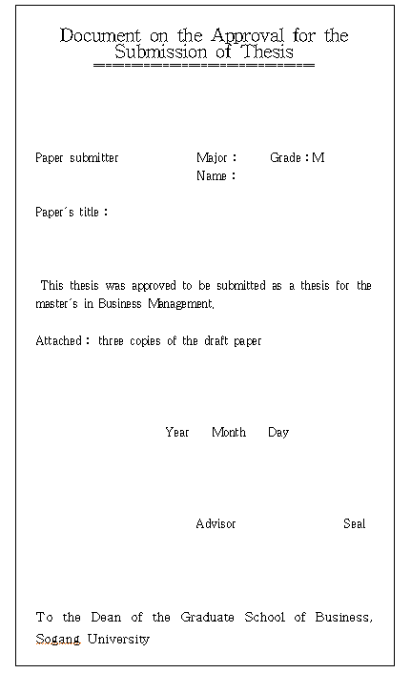

<Attachment No. 2>
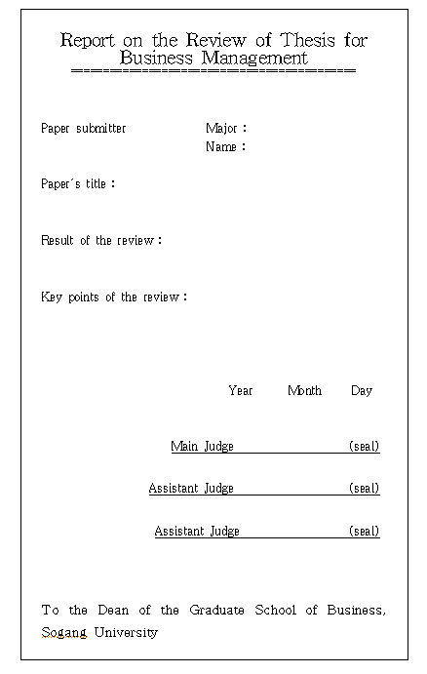

<Attachment No. 3>
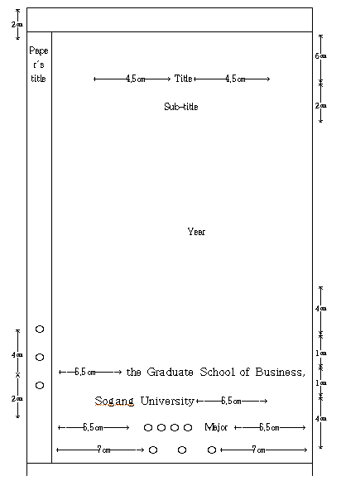
(1) When paper's title requires two lines, then space the lines by 2cm.
(2) Year, recorded on the outer cover is the year of graduation.
(Example∶ In case of the party earning degree on February or August 1993, write 1992)

<Attachment No. 4>
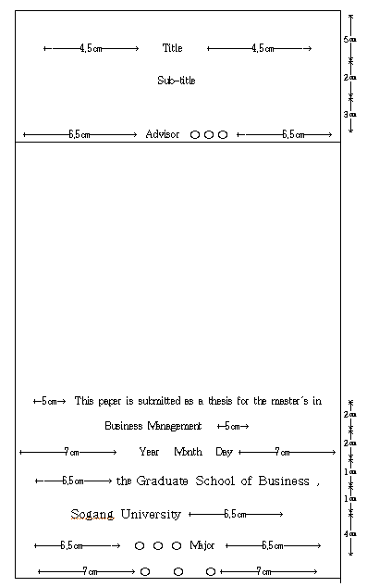
(Write in the day of thesis submission for the date)

<Attachment No. 5>
